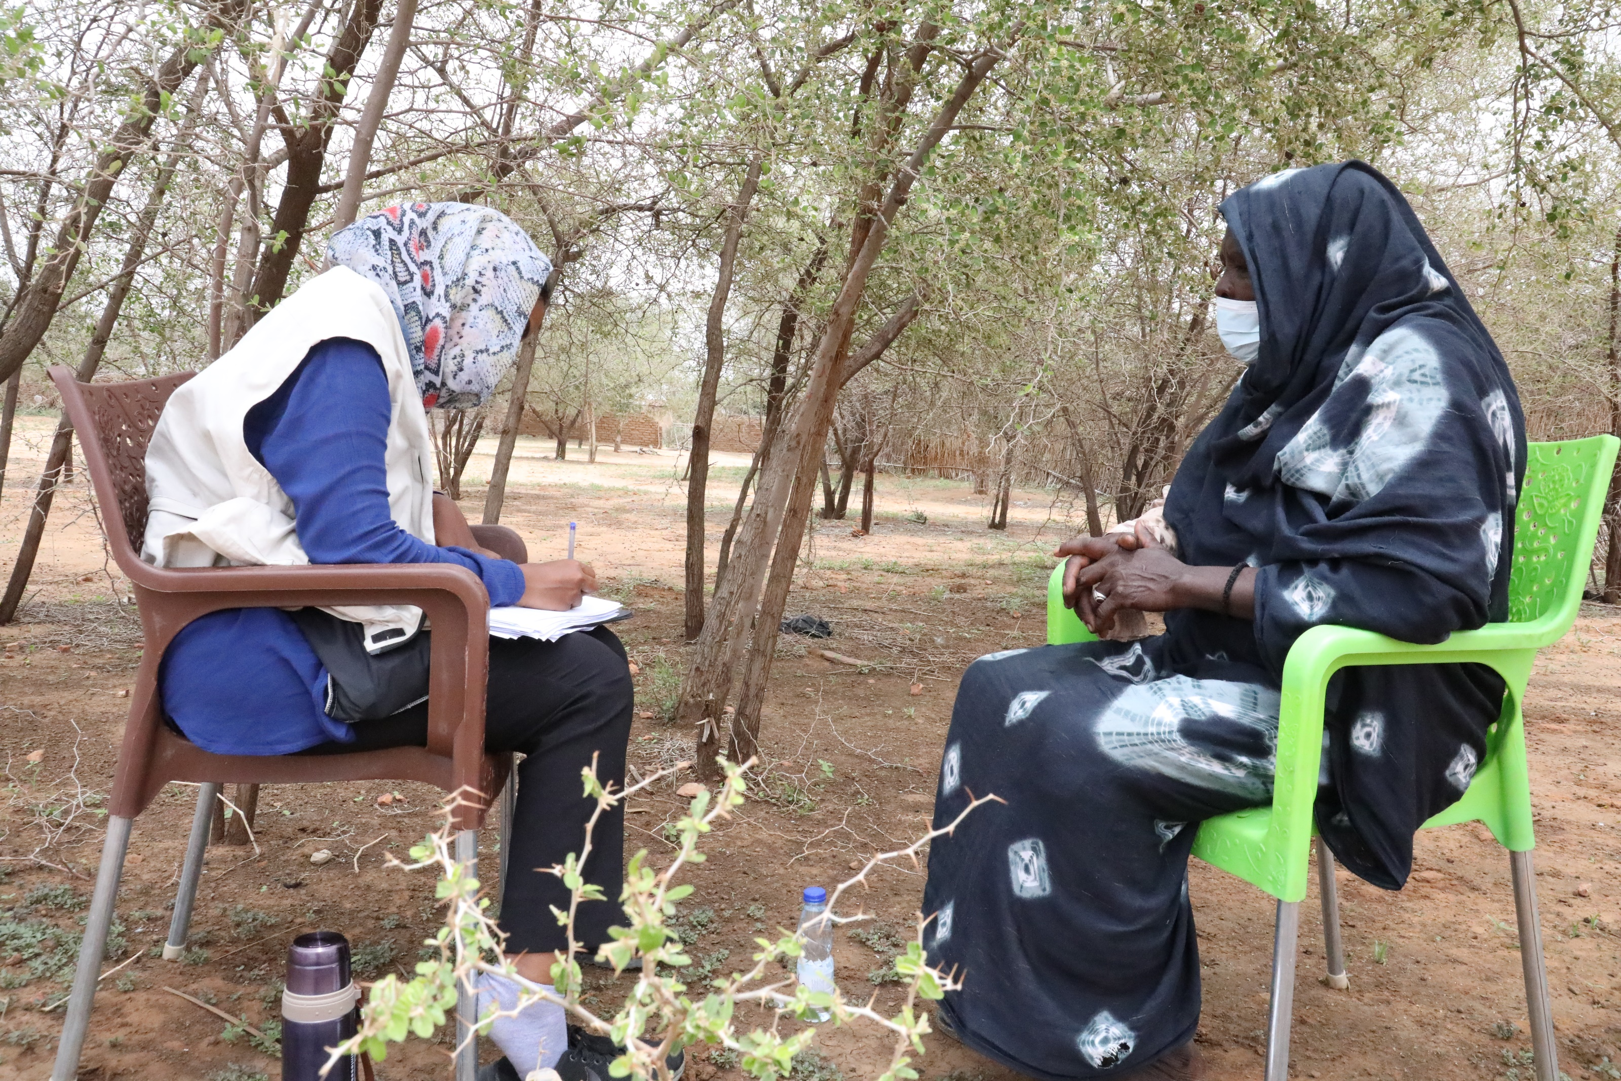
INFORMATION SHEET ON
LEGAL IDENTITY & CIVIL DOCUMENTATION
STEPS OF ACQUIRING LEGAL IDENTITY
The Norwegian Refugee Council (NRC) is an independent humanitarian organization helping people forced to flee. We work in crises across 31 countries, providing life-saving and long-term assistance to millions of people every year.
NRC works to protect the rights of displaced and vulnerable persons during crisis. In Sudan, NRC is implementing programmes under the Water sanitation and hygiene, Food security and Livelihoods, Education, Shelter and settlement, Camp coordination & camp management, Information counselling & Legal Assistance areas of competence.
Information, Counselling & Legal Assistance (ICLA) is a legal aid programme seeking to assist displaced persons to claim and fulfil their rights through application of information, counselling and legal assistance services.
In Sudan NRC ICLA conducts activities on Housing Land and Property (HLP) issues , Civil and Identity Documentation and Employment laws and procedures.
THE NORWEGIAN REFUGEE COUNCIL
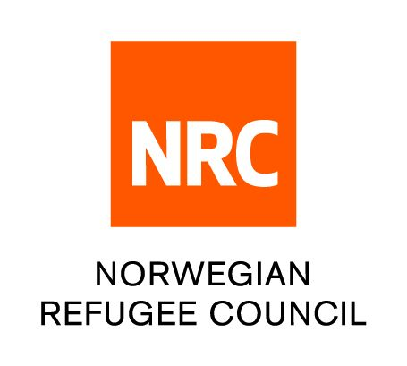
All information provided in this document is intended as a general guide only and is not a substitute for seeking advice from a qualified lawyer and/or government authorities. The information in this leaflet is subject to change and individuals should ensure that they obtain up to date information

Steps of acquiring legal identity – National ID, National Number, Refugee ID Card

- National Number
All Sudanese nationals registered at the Civil Registry will be issued with a national number. It is a unique number issued to all citizens which does not change even if other information changes.
Documents required;
- Birth certificate
- One male witness from the paternal ascendants (father, uncle etc.) if they are in possession of a national number, national ID or a birth certificate
- Two passport photos.
- Proof of occupation, if any. (Optional)
- Duly filled form.
- Fee – it is free to obtain the national number.
Procedure of obtaining the national number
- Once you have obtained all the documents above, visit the civil registry office in your State.
- Once you enter you will find an officer sitting in the reception who will direct you to the window where you will be served.
- Processing time is 5 working days
Replacement of national number attracts fee of 1700 SDG
NB: The old identity cards "that do not contain a national number are no longer valid. All Sudanese citizens are strongly encouraged to reapply to get the new identity card.

- National ID Card
The national identity card is the official document for the identification of its holder. No one shall refuse the admission of the national identity card number.
Documents required;
- A copy of the National Number document - you must have a national number to obtain the national ID card.
- Any previous Identification documents or proof of birth (Birth certificate)
- Filling the required form.
- Citizenship certificate - For those who are 18 and above, having a nationality certificate is a prerequisite for acquiring a national number
- Payment of the fees is 6000 SDG
Procedure of obtaining national ID card
- Once you have obtained all the documents above, visit the civil registry office in your State.
- Once you enter you will find an officer sitting in the reception who will direct you to the window where you will be served.

- Refugee Card
The refugee identity card is the main identification documents for refugees in Sudan. Obtaining the refugee card helps protect asylum seekers against forced return, deportation, arbitrary arrest and detention. UNHCR and the Commission for Refugees are responsible for issuing a refugee identity card, to every refugee based on the fulfilment of certain criteria set for the refugee status determination procedures. The Refugee ID card is valid for two years and renewable for another two years
Locations of the civil registry in North Dafur State:
- El fasher - south of Alfasher Market next to Almozdawja primary School
- Kutum - West of Kutum Rural hospital

THE DIGITAL COMMUNITY HUB
- Call NRC for free on 015 655 9807
- Information available in English, Arabic, Tigrinya and Amharic (from 8:00 AM to 4:00 PM every day).
- If you are a Refugee or Internally Displaced Person in Khartoum, get information on obtaining legal documents and on our Cash for Food Programme.
- The call will not cost you anything.
- You can also leave us a message with your complaint or feedback on our services and we wll get back to you (Sunday - Thursday, between 8:00 AM and 4:00 PM)

www.nrc.no

